Survivorship Notes
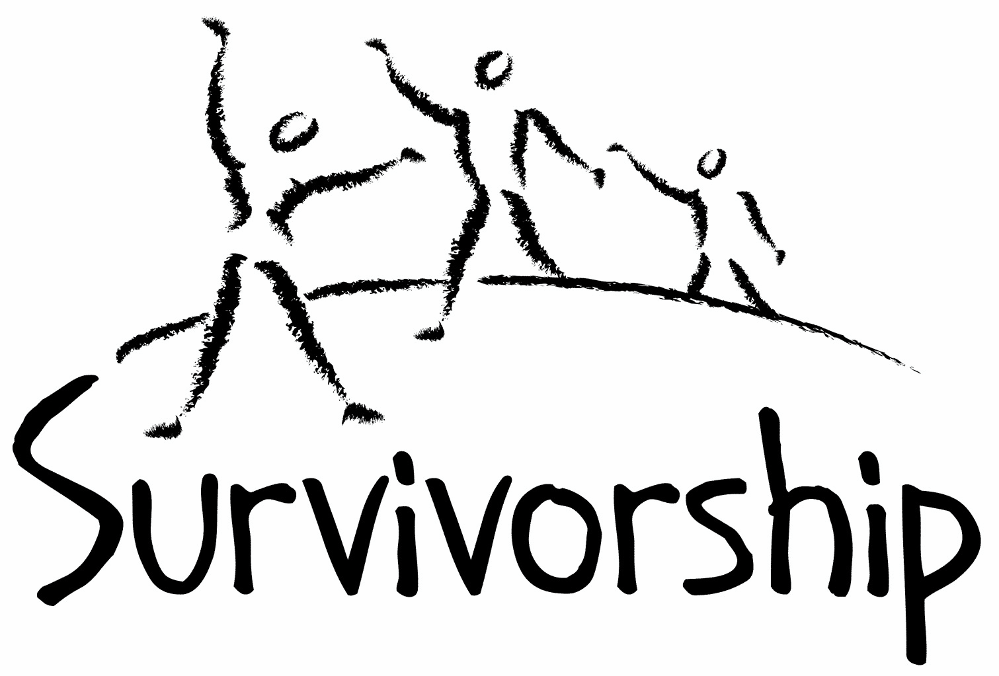

Vol. 189 No. 9 and 10
September/October, 2015

The Notes, formerly called Chart Notes, ISSN 1523-275, is published bimonthly, copyright © 1999-2015 by Survivorship, Family Justice Center, 470 27th Street, Oakland, CA 94612. All rights reserved. The entire contents of this issue are copyrighted by Survivorship and by the individual contributors. Contact Survivorship, or email info@survivorship.org for permission to reprint. Survivorship is a nonprofit organization.

Dear Survivorship Community,
We have made several changes to our board of directors this summer. We would like to say goodbye to Spence and thank him for his work on the board and Survivorship Notes. We wish him success in his future endeavors. We have added two new temporary members to our board of directors, Alison Miller and Wendy Hoffman. They both have a lot of experience helping survivors of ritual abuse.
Alison Miller is a clinical psychologist in private practice in Victoria, British Columbia, Canada. She is the author of 2012's Healing the Unimaginable: Treating Ritual Abuse and Mind Control (for therapists) and 2014's Becoming Yourself: Overcoming Mind Control and Ritual Abuse (for survivors), both published by Karnac Books.
Wendy Hoffman somehow survived various forms of high level secret mind control. She tried all her life to get free and has finally succeeded. Now she wants to help and support other survivors in their quest for freedom. She is a LCSW-C with decades of experience and is the author of The Enslaved Queen, a Memoir about Electricity and Mind Control, published in 2014 by Karnac Books, London.
We will keep our members updated on our conference plans for next year and let people know more in our next notes.
The Survivorship Board of Directors
Micci, Neil, Alison and Wendy

Survivorship blog https://survivorshipwp.wordpress.com
Survivorship on Twitter https://twitter.com/Survivorshiporg Survivorship on Facebook https://www.facebook.com/SurvivorshipRitualAbusePage
Ritual Calendar 2015- Difficult Days
September
9/1 Start of WW11
9/4 Birthday celebration of Shri Krishna
9/5-9/7 Marriage to the Beast (Satan)
9/7 Feast of the Beast, marriage of virgins to Satan
9/7 Labour day
9/13 New Moon
9/13 Partial Lunar Eclipse
9/13 Grandparents Day
9/15 Rosh Hashana (Jewish New Year)
9/17 Ganesh Charurthi; Hindu: Birth of Lord Ganesha, god of wisdom, prosperity, and good fortune
9/18-22 Durga Puja
9/27-10/4 Sukkot
9/20-9/21 Midnight Host, vows, blood sacrifice from tip of finger
9/21 Fall Equinox
9/28-10/12 Pitr Paksha: Hindu 16 day period when spirits visit their descendant’s home
9/21 Rituals of the Elements and Feast of the times
9/23-10/2 Mysteries of Eleusis
9/28 Full Moon
9/28 Solar Eclipse
9/25-10/3 Navaratri: Hindu: Fall Festival, Worship of Durga. Lakshmi ans Saraswati
9/29 Michaelmas

October
10/4 Simchat Torah
10/5 Opening of Mundus Ceresis
10/12 Thanksgiving: Canada
10/12 Columbus Day:US
10/12 Dia de la Raza: Mexico
10/12 Hitler’s half birthday
10/13 New Moon
10/13 Backwards Halloween
10/14 Thanksgiving Day in Canada
10/15 Death of Goering
10/16 Death of Rosenburg
10/22 Ashara (Kali’s victory over Mahishasura)
10/22-10/29 Preparation for all Hallow’s Eve
10/27 Full Moon
10/24 United Nations’ Day
10/31 Halloween/Samhain/All Hallow’s Eve/ Hallomas/ All Souls Day
10/31 Preparation for the Isia (ring of six: Isis, Hathor, Nepthys, Horus, Thoth, Anubis) Resurrection of Osiris
10/31 Start of the Celtic new year. Dark half of the year

CONFERENCES, WEBINARS, WORKSHOPS, AND TRAINING
Male Survivor: Weekends of Recovery
September 18- 20, 2015 Alta Level 1 Alta, UT October 16 – 18, 2015 Hope Springs Level 1 Peebles, OH http://www.malesurvivor.org/weekends/2015/schedule.html
PODS - POSITIVE OUTCOMES FOR DISSOCIATIVE SURVIVORS (PODS)
Trauma and the Body: Somatisation and Dissociation
Belfast: October 17
Birmingham: November 14
Rotherham: March 19, 2016
Bradford: July 2, 2016
Nottingham: July 16, 2016
London. “Working with Relational Trauma - Dealing with Disorganised Attachment” September 26
Darlington: December 5
Huntingdon: February 26, 2016
Bristol: February 27, 2016
Bristol: March 5, 2016
Brighton: April 23, 2016
London.
Trauma, Dissociation and Recovery: Working with Dissociative Identity Disorder and Complex PTSD.” November 7
Crawley: November 27
Bristol: November 28
Bristol: January 30, 2016
Darlington: February 6, 2016
London: May 7, 2016
Rotherham: May 14, 2016
Exeter: October 15, 2016
London: November 12, 2016
Brighton: November 26, 2016
info@pods-online.org.uk http://www.pods-online.org.uk/events.html

1in6 Webinar: Engaging Men Sexually Abused in Childhood
September 16, 2015 @ 9:30 am - 11:00 am
1in6 Webinar: Responding to Men Sexually Abused in Childhood: Hotline Practices
October 21, 2015 @ 9:30 am - 11:00 am
Contact Martha Lucia Marin at Martha@1in6.org to register for info on upcoming webinars.
https://1in6.org/therapists-and-other-professionals/books-and-films/ptsd-and-dissociation/

Eleos Support Network
November 14-15, 2015
“Organized Criminal Abuse of Children: Taking a Closer Look”
Carco Theater Renton, Washington
www.eleossupportnetwork.org
Presenters include Michael Salter and Alison Miller

TALOMIN BOOKS
"Treating Complex Trauma."
Presenter: Leah Giarratano
October 22 - 23, Adelaide
October 29 - 30, Perth
November 5 - 6, Brisbane
March 10 - 11, 2016, Singapore.
Information: https://www.talominbooks.com/html/store/training/details.asp?prodid=198

Bessel van der Kolk's complete speaking schedule is at:
http://www.traumacenter.org/about/speaking_schedule.php http://www.traumacenter.org/training/workshops.php

Organized Ritual Violence
September 5, 2015 Bremen, Germany nivt@nivt.de www.nivt.de

IVORY GARDEN
2015 Annual International Trauma and Dissociation Conference: "How the Past Affects the Now."
October 16 - 18, Seattle, WA.
Presenters include: Alison Miller (all day Friday), Steven Frankel (all day Saturday), Lynn Crook, Joan Golston, Robin Shapiro, Rich Loewenstein, Laura Brown. Information: http://igdid.org/

International Conference on Innovations in Family Engagement
Dates of Conference: 10/27/2015 - 10/30/2015
Location: Minneapolis , MN
Contact Information: Amy Hahn
For more information, contact: amy.hahn@childrenscolorado.org

THE MEADOWS
Second International Conference on Sex and Love Addiction: "The Changing Architecture of Addictive Desire, Trauma and Attachment: Families, Children and Partners."
November 12 - 14, Fort Lauderdale, FL.
Presenters include: Patrick Carnes, Bessel van der Kolk, Claudia Black, Donald L. Hilton, Helen Fisher, Rob Weiss, Pat Love, Ken Adams, and Stephanie Carnes.
Information: http://www.usjt.com/Conferences/2014/2nd-Intl-Conference-On-Sex-and-Love-Addiction

Workshops for survivors, therapists, family and friends. For dates and other information, click the workshop titles at the left on http://www.themeadows.com/workshops/survivors-i-workshop
Survivors I
Survivors II
Strengthening Coupleship: Working Together
Love Addiction / Love Avoidance
Family Workshop
Men's Sexual Recovery
Journey Of A Woman's Heart: Finding True Intimacy
Healing Intimate Treason: For Partners of Sex Addiction
Healing Heartache: A Grief And Loss Workshop
Spirit: A Somatic Equine Workshop
Mind and Heart: A Mindful Path To Wholehearted Living

Conference on Child Abuse and Neglect
May 22 - 25, 2016 Stockholm, Sweden.
http://www.nfbo.org/web/page.aspx?sid=7799

NEWS AND LINKS

Bill Cosby: 35 Women Accuse the Actor of Assault on New York Magazine Cover
http://abcnews.go.com/Entertainment/bill-cosby-35-women-accuse-actor-assault-york/story?id=32710622

‘I’m No Longer Afraid’: 35 Women Tell Their Stories About Being Assaulted by Bill Cosby, and the Culture That Wouldn’t Listen http://nymag.com/thecut/2015/07/bill-cosbys-accusers-speak-out.html

Child sex abuse inquiry: Leon Brittan among leading Westminster figures named in documents
http://www.dailyrecord.co.uk/news/uk-world-news/child-sex-abuse-inquiry-leon-6119976

Jehovah's Witnesses failed to report 1,000 alleged perpetrators, child sex abuse royal commission hears
http://www.abc.net.au/news/2015-07-27/jehovahs-witnesses-child-sexual-abuse-royal-commission/6649340

Milwaukee archdiocese settles with clergy abuse survivors for $21 million
The Roman Catholic Archdiocese of Milwaukee said Tuesday that it will pay $21 million to more than 300
http://www.usnews.com/news/us/articles/2015/08/04/apnewsbreak-milwaukee-archdiocese-settles-for-21-million

TLC cancels ‘19 Kids and Counting’ amid Josh Duggar abuse scandal
http://www.nydailynews.com/entertainment/tv/tlc-cancels-19-kids-counting-duggar-abuse-scandal-article-1.2294251

Rotherham child sex abuse: Most victims have not yet come forward for help, says lawyer The Jay Report estimated that more than 1,400 children were sexually exploited http://www.independent.co.uk/news/uk/crime/rotherham-child-sex-abuse-most-victims-have-not-yet-come-forward-for-help-says-lawyer-10468543.html

Edward Heath abuse claims: Five forces investigating ex-PM Edward Heath, who was prime minister from 1970 to 1974, died in 2005 http://www.bbc.com/news/uk-33770021

Number of arrests in child abuse scandal rises to 14 - Pakistan
Investigations into the massive child sexual abuse scandal – termed the biggest in the country's history – revealed that around 400 videos were made of 280 minor victims of sexual abuse by the organised gang of over 25 criminals. http://www.geo.tv/article-193765-Number-of-arrests-in-child-abuse-scandal-rises-to-14

We Asked an Expert on Ritual Murders About the Triple Homicide in the Florida Panhandle
http://www.vice.com/read/we-asked-an-expert-in-ritual-murders-about-the-triple-homicide-in-the-florida-panhandle-806

US torture doctors could face charges after report alleges post-9/11 'collusion'
Leading group of psychologists faces a reckoning following repeated denials that its members were complicit in Bush administration-era torture
http://www.theguardian.com/law/2015/jul/10/us-torture-doctors-psychologists-apa-prosecution

PSYCHOLOGISTS FOR SOCIAL RESPONSIBILITY PsySR Responds to Hoffman Report about APA Collusion http://www.psysr.org/about/statements/PsySR_Statement-Hoffman_Report.pdf

Elizabeth Loftus and the Hoffman Report
http://blogs.brown.edu/recoveredmemory/2015/07/22/loftus-hoffman-report/

What Beck Left Out By Ross E. Cheit
Richard Beck, a comparative literature major from Harvard who works at a literary magazine, is the latest one spreading the witch-hunt narrative about those cases. His book, We Believe the Children, based largely on secondary sources.... In both instances, the authors repeatedly omitted significant evidence that contradicts the witch-hunt narrative. http://blogs.brown.edu/rcheit/2015/08/08/what-beck-left-out/

Former Subway spokesman Jared Fogle to plead guilty to child pornography charges
http://fox59.com/2015/08/18/former-subway-spokesman-jared-fogle-to-plead-guilty-to-child-pornography-charges/
ON-GOING MEETINGS AND TRAINING OPPORTUNITIES
More information is available at https://survivorship.org/community-calendar-of-events/

Adult Survivors of Child Abuse-ongoing meetings/Beyond Surviving
Second Thursday of each month, 6:00-8:00 PM
Embarcadero YMCA, 169 Steuart St., San Francisco, CA
http://rachelgrantcoaching.com/

ASCA (Adult Survivors of Child Abuse)
On-going meetings in CA, FL, IL, NE, NJ, NY, NC, RI, and South Africa
info@ascasupport.org
www.ascasupport.org

Christina Arguello
http://therapists.psychologytoday.com/rms/prof_detail.php?profid=119345&sid=1336589023.0802_18054&city=San+Francisco&county=San+Francisco&state=CA&spec=19
Intensive Trauma Therapy, Morgantown, WV.
Free Thursday morning Trauma Seminars
info@traumatherapy.us
http://www.traumatherapy.us
Safeguarding Children - Ongoing training North Yorkshire, UK http://www.safeguardingchildren.co.uk/lscb-training-brochure.html
Survivors of Incest Anonymous
SIA holds 12-step meetings for incest survivors. Those designated “Nothing Too Heavy to Share” meetings are designed for ritual abuse survivors.
410-282-3400
http://www.siawso.org

SIA Coming Home phone meeting
Daily at 11:30 am and 9pm Eastern time.
1 712 432 8808 code is 742247 then press 5 once you're in.

Trauma Center at JRI
Free lecture each Thursday of the month, 12-1 p.m., Brookline, MA
moreinfo@traumacenter.org
617- 232-1303
www.traumacenter.org/training/workshops.php

Womencare Counseling Center
Weekly ongoing groups, Evanston, IL
info@womencarecounseling.com

847-475-7003
www.womencarecounseling.com

Women’s Center, 46 Pleasant Street, Cambridge, MA

Weekly and monthly groups for survivors of child sexual abuse, incest survivor’s interfaith quilt project, Survivors of Incest Anonymous, eating disorder support group, emotional healing group, more.
info@cambridgewomenscenter.org
Phone: 617-354-6394
Helpline. 617-354-8807
http://www.cambridgewomenscenter.org

Dissociation & Trauma Clinical Discussions
The Dissociation & Trauma Clinical Discussions (DissTCD) list has been created to allow for clinical discussions for all licensed mental health counselors and retired licensed mental health counselors around the world. If you have a related license or degree, please write for more information at DissTCD-owner@yahoogroups.com http://groups.yahoo.com/group/DissTCD

Ritual-Abuse/Mind-Control Special Interest Group
The Ritual Abuse and Mind Control Special Interest Group (RA/MC SIG) of the International Society for the Study of Trauma and Dissociation (ISSTD) was approved by ISSTD’s Executive Council in 2008. The Mission of the RA/MC SIG is to further dialogue, knowledge, research, and training on the etiology, evaluation, and effective treatment of trauma and dissociation in clients reporting histories of ritual abuse or mind control. Membership in the RA/MC SIG is free to all ISSTD members as an ISSTD membership benefit. To join the RA/MC SIG, please contact: Ellen Lacter: ellenlacter@earthlink.net Ann Beckett: ann_at_stgeorgestreet@yahoo.ca

Survivorship is presenting this as information and cannot guarantee your safety. If you choose to get involved, please know that you are choosing to do this at your own risk. We advise having support systems in place before reading.

The Childhelp National Child Abuse Hotline 1-800-4-A-CHILD (1-800-422-4453)

HOTLINES FAMILIAR WITH RA ISSUES

* Bay Area Women Against Rape (BAWAR): 510-845-7273
* San Francisco Women Against Rape (SFWAR): 415-647-7273
* Women’s Center, Cambridge, MA: 617-354-8807

